**FAKE NEWS DETECTION USING NLP**

**ABSTRACT**

Fake news has become a pervasive issue in the digital age, leading to misinformation and its harmful consequences. This project presents a comprehensive approach to combat fake news by leveraging Natural Language Processing techniques. The goal is to develop a robust and efficient system capable of automatically detecting fake news articles.

This project involves several key components, including data collection, preprocessing, feature extraction and machine learning model development. This project employs NLP tools to process and analyze textual content, extracting valuable features that can help discern fake from genuine news. Additionally, the dataset used for training and evaluation is carefully curated to ensure diversity and reliability. Several machine learning algorithms, including but not limited to neural networks, support vector machines and ensemble methods, are explored and compared for their effectiveness in fake news detection. Furthermore, this project incorporate linguistic analysis, sentiment analysis and fact checking techniques to enhance the model’s accuracy and reliability.

**INTRODUCTION**

The fake news has been rapidly increasing in numbers it is not a new problem but recently it has been on a great rise. Detecting the fake news has been challenging and a complex task. It is observed the humans have a tendency to believe the misleading information which makes the spreading of fake news even easier. Fake news is dangerous as it can deceive people easily and create a state of confusion among a community. This can further affect the society badly. The spread of fake news creates rumour circulating around the victims could be badly impacted. Fake news might be created by people or groups who are acting in their own interests or those of third parties. **Natural Language Processing (NLP)** offers a powerful toolkit to tackle this issue by enabling automated analysis and classification of textual content. In this field, NLP techniques are applied to identify misleading or fabricated information in new articles, social media posts and other text sources.

**NLP**

Natural Language Processing (NLP) is a field of artificial intelligence (AI) that focuses on the interaction between computers and human language. Its primary goal is to enable machines to understand, interpret, and generate human language in a way that is both meaningful and useful.

**THE KEY ASPECTS OF NLP:**

1.Language understanding:

* Tokenization.
* Part- of -speech Tagging.
* Syntax Parsing.
* Named Entity Recognition (NER).
* Sematic Role Labeling.

2.Language Generation.

3.Sentiment Analysis.

4.Information Retrieval.

5.Qustion Answering.

6.Language Models.

7.Challenges in NLP:

* Ambiguity.
* Context.
* Data Quality.
* Multilingualism.

8.Applications:

NLP has a wide range of applications such as virtual assistants (like Siri, Alexa), language translation services (like google translate), content recommendation systems (like Netflix recommendations) and healthcare .

**FLOW CHART**

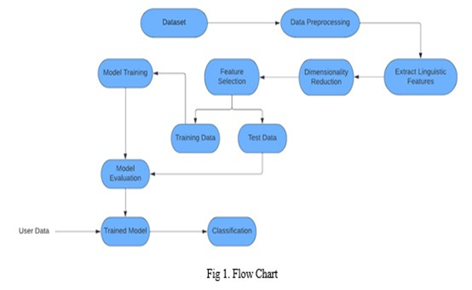

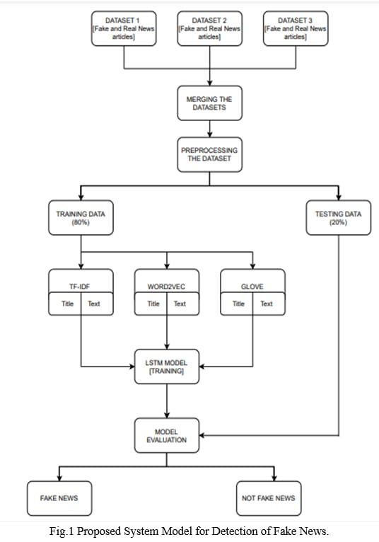**BLOCK DIAGRAM**

**CONCLUSION**

In conclusion, fake news detection using NLP is a pivotal endeavor in our era of information dissemination. Through advanced NLP techniques and machine learning, this project aims to safeguard the integrity of information. While challenges persist, such as evolving tactics and ethical considerations, ongoing research and collaboration are essential. The ultimate goal is to provide the public with accurate, trustworthy information, thereby mitigating the harmful impact of misinformation in an interconnected world.